CHAPTER 2: Getting into genes

Worksheet 2.2

DNA
Answers

Nucleotides and DNA
1. The following images show a section of DNA and the composition of a nucleotide.
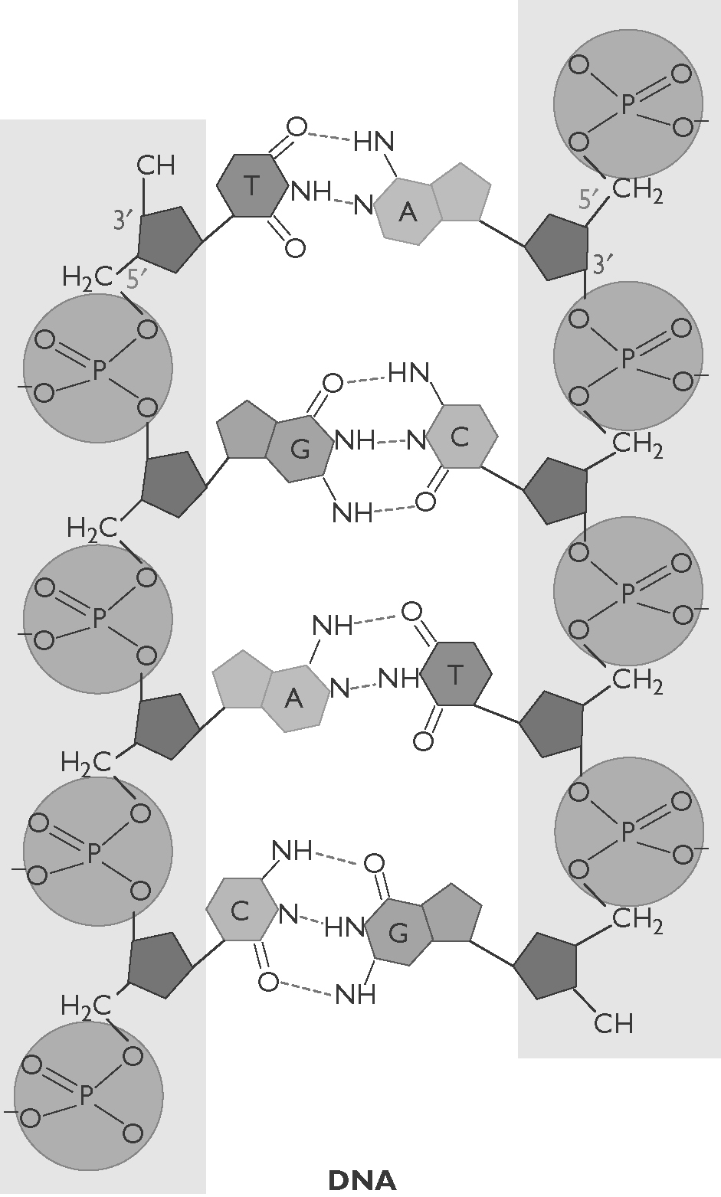 | 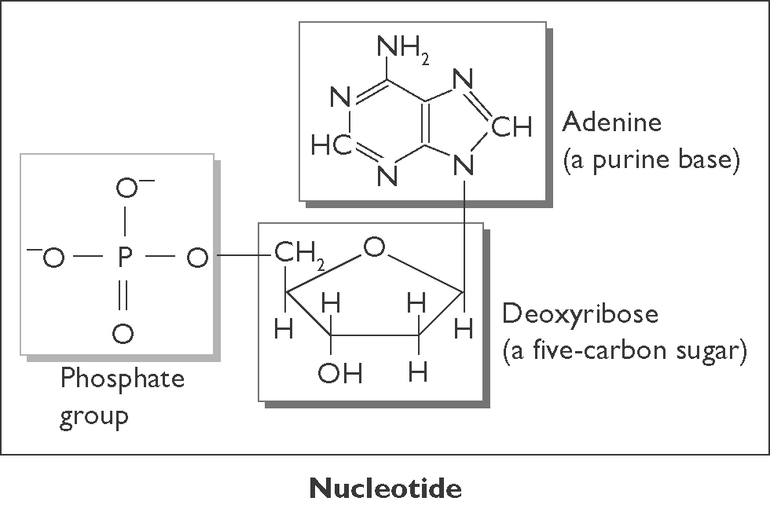  (a) Describe the structure of DNA in terms of nucleotides.  The DNA molecule is composed of  2 chains of 4 different nucleotides.  (b) Identify the molecules in the nucleotides that form the ‘backbone’ of the DNA ‘ladder’.  Deoxyribose sugar and a phosphate group
(c) State the pairing arrangement of the four types of nitrogen bases.
A binds to T, and G binds to C.

CHAPTER 2: Getting into genes

Worksheet 2.2

Page 2

Two stranded DNA
2. The following diagram is a simplified section of the double-stranded DNA molecule.
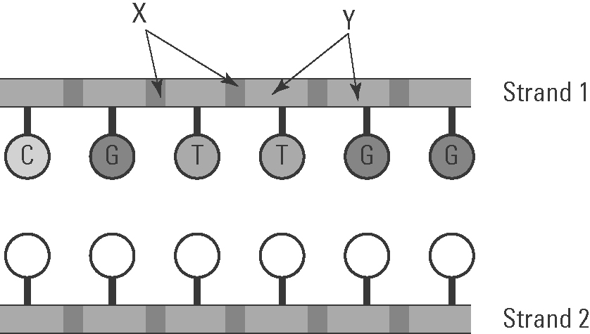 | (a) Identify components X and Y.  Phosphate  X: ............................................................  Deoxyribose sugar  Y: ............................................................

(b) In strand 2 on the diagram, record the letters of the matching nucleobase (nitrogen base).
Base order (L to R) = G, C, A, A, C, C

(c) What shape is a DNA molecule?
Double helix

Guanine and cytosine
3. The structures of guanine and cytosine are shown below.
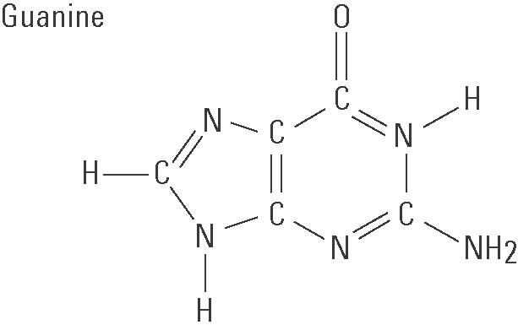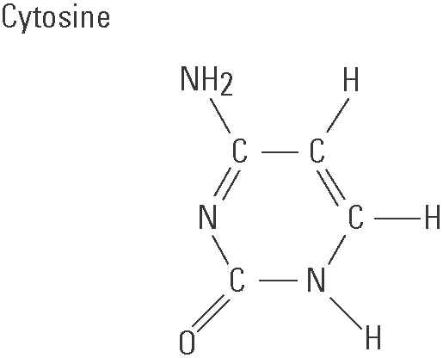

(a) Count the number of C, H, N and O atoms in each molecule.
Guanine:
5 5 5 1
C: ............ H: .............. N: .............. O: ............
Cytosine:
4 5 3 1
C: ............ H: .............. N: .............. O: ............
(b) Write the chemical formula for each molecule.
C₅H₅N₅O
Guanine: ...........................................................
C₄H₅N₃O
Cytosine: ..........................................................

